Image data Augmentation and Image Classification

Koushiki Maity
Ba Eco (Hons) 2025-2028 – Mount Carmel College
Period of Internship: 18th May 2026 – 14th June 2026

Report submitted to: IDEAS – Institute of Data Engineering, Analytics and Science Foundation, ISI Kolkata
- Abstract
The project is based on basic image processing, image augmentation and image classification techniques using python libraries like OpenCV, PyTorch and Scikit-learn. I did some image transformations like converting images to grayscale, shifting, resizing, rotating images using opencv. To understand about data augmentation I worked with a Cat and Dog image dataset and applied techniques like resizing and random flipping in order to prepare the images for machine learning models. Then, I created datasets and dataloaders in PyTorch to efficiently manage large amounts of image data. This project also helped me to learn image classification with MNIST handwritten digits dataset. I used the K-Means clustering algorithm to cluster similar images of digits into ten clusters and compared the results with the actual labels of digits. The clustering performance was measured by the Macro F1 Score. This project gave me hands on experience in image preprocessing, data augmentation, machine learning workflows and model evaluation.
- Introduction
The rapid growth of Artificial Intelligence (AI) and Machine Learning (ML) has made Image processing and Image classification an important area of research and real-world applications. These technologies are widely used in facial recognition systems, medical image analysis, autonomous vehicles, security surveillance and many other domains. Any person learning data science and machine learning has to know how computers understand and classify images. One of the main parts of the project was image augmentation. Image augmentation is a technique that artificially increases diversity of your training data. It does so by applying transformations to images, such as flipping, resizing, etc. Data augmentation aids machine learning models to generalize better and also reduces chances of overfitting. The project also included image classification concepts using the MNIST handwritten digit dataset. Machine learning techniques were used to cluster the similar digit images using K-Means clustering. To gain insight into model performance and evaluation metrics, the clustering results were evaluated using the Macro F1-Score. The project used several modern technologies and libraries including Python, NumPy, OpenCV, PyTorch, TorchVision and Scikit-learn. The tools are popular in the domains of machine learning, data science and computer vision due to their efficiency and wide functionalities.
The methodology adopted in this project was image loading, preprocessing, augmentation, dataset creation, data loading, clustering and performance evaluation. Each step helped build a better understanding of how machine learning workflows are deployed in real-world environments. The aim of this project was to gain practical experience in image processing, data augmentation, dataset management and machine learning techniques using Python. The project was to perform image transformations such as grayscale, shift, resize and rotation using OpenCV. These preprocessing techniques help improve the quality of the image and prepare the data for machine learning models.
Overall, this project was a good first but complete learning experience in the area of image processing and image classification. The course not only enhanced the theoretical knowledge and the practical implementation skills but also provided hands-on exposure to the industry-standard tools and techniques used in computer vision and machine learning.
- Project Objective

- Learn and build core image processing techniques such as Grayscale conversion, image scaling, Rotation and Translation using OpenCV which are used extensively in medical imaging, surveillance systems and facial recognition applications

- To study image augmentation methods such as resizing and random flipping to increase the diversity of the data set and to increase the robustness and accuracy of machine learning models used in computer vision tasks.

- To learn to work with large image datasets with the help of PyTorch tools like ImageFolder and DataLoader which are used in real-world deep learning projects.

- To understand the concepts of image classification and pattern recognition using the MNIST handwritten digit dataset, and application of K-Means clustering which is widely used in customer segmentation, image segmentation and data analysis.

- To evaluate the effectiveness of machine learning algorithms using performance metrics such as the Macro F1-Score and understand the importance of model assessment in developing reliable AI systems.

- Methodology
The project was done in several stages starting from image processing and finishing with image classification and evaluation. The main programming language used was Python and libraries such as OpenCV, NumPy, PyTorch, TorchVision, Matplotlib and Scikit-learn were used for image manipulation, dataset management, visualization and machine learning tasks.
  - Data Collection and Processing
The project used two datasets:
- Image dataset of cat and dog for dataset handling & image augmentation.
- MNIST Handwritten Digit Dataset for studying clustering and classification.
The datasets were downloaded and placed in appropriate folders and loaded to the Python environment for further processing.

  - Image Processing
Various image processing operations were performed using OpenCV to understand how images can be transformed before using them in machine learning models. The operations comprised:
- Convert to Grayscale
- Image Translation (Changes)
- Rotate Image
- Resize pictures
These preprocessing methods help to improve the quality of images and prepare the data for analysis .

  - Data Augmentation
Data augmentation techniques were applied to the Cat and Dog dataset using TorchVision transforms. The techniques used were:
- Resizing Images
Random Horizontal Flip
- Convert to Tensor Format
Data augmentation is useful to diversify datasets and improve the performance and generalization capability of machine learning models.

  - Loading and Managing Dataset
The image datasets were organized using the ImageFolder class and DataLoader was used to efficiently load and process the images in batches. This step becomes important in deep learning applications when dealing with large datasets.

  - Image Classification and Clustering Analysis
The MNIST dataset of handwritten digit images was used to study the concepts of image classification. We clustered similar images into 10 clusters representing the digits 0-9 using K-Means Clustering. The clustering algorithm found patterns in the image data without using pre-existing labels.

  - Model Assessment
The performance of the clustering process was evaluated by the metric of Macro F1-Score. For the obtained cluster labels, the most frequent actual label was mapped and the resulting F1-Score was calculated to evaluate the effectiveness of classification.

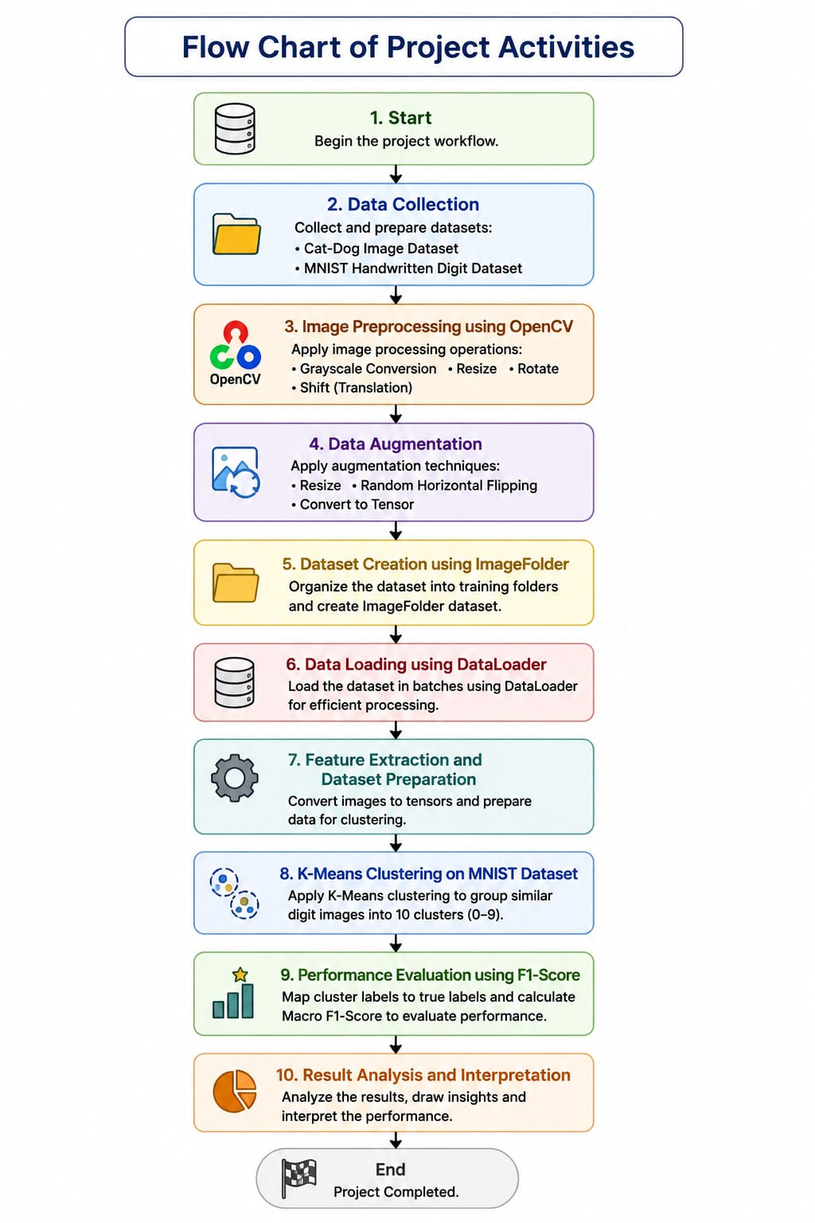
- Data Analysis and Results
DESCRIPTIVE ANALYSIS
- Image Properties Summary (OpenCV Pre-processing)
The moon-pexels-frank-cone image was used as the base for augmentation exercises. The table below records shape outputs at each transformation stage .
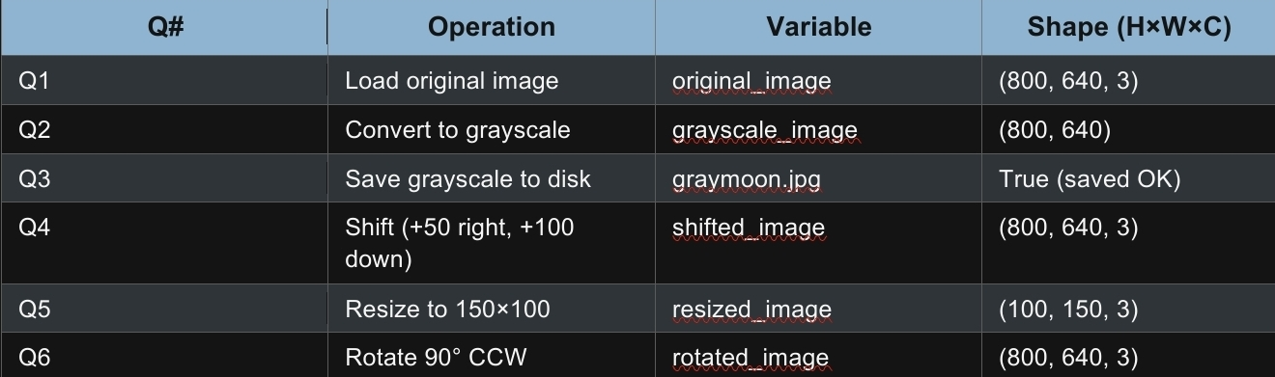

Key observations:
• The conversion to grayscale eliminates the color channel, changing (800, 640, 3) → (800, 640).
• Shifting & rotation maintain the original canvas size (800×640×3).
• Resizing to (150, 100) reverses the natural order: OpenCV stores (height, width, channels), so an image with width 150 and height 100 ends up with shape (100, 150, 3).
• 90° CCW rotation swaps height and width (expected), but warpAffine call keeps the original canvas, so shape is (800, 640, 3).
- Cat/Dog Dataset Statistics
The Udacity Cat & Dog dataset (~554 MB) was downloaded and unzipped from S3. An ImageFolder scan on the train split reported the totals below.
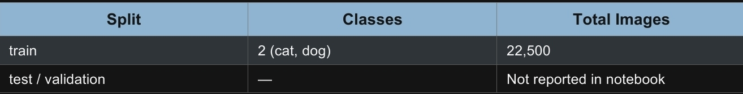
- Data Loader Batch Statistics
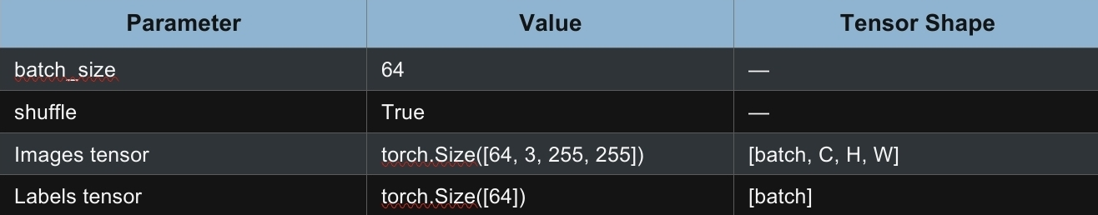
- MNIST Digits Feature Dataset
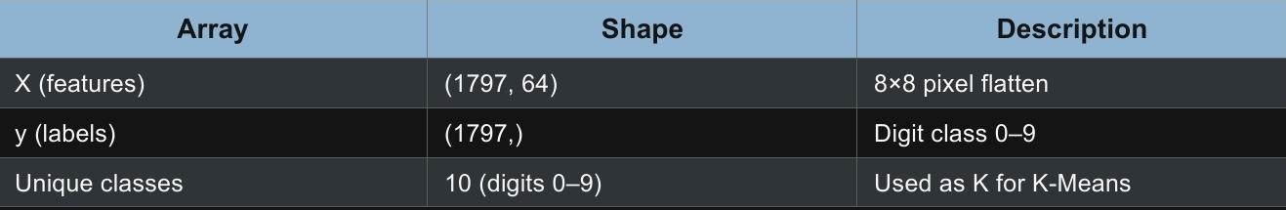
MACHINE LEARNING ANALYSIS
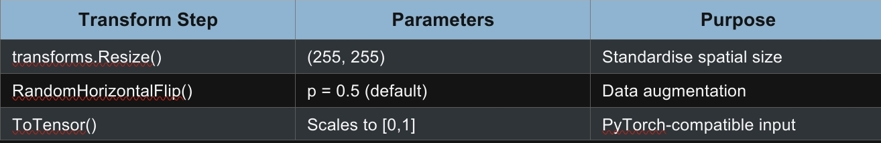
- IMAGE TRANSFORM PIPELINE

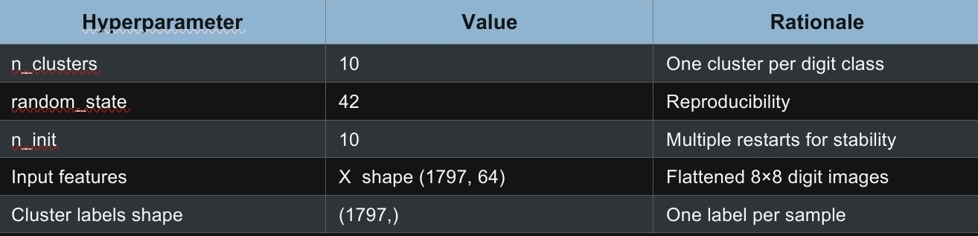
- K-MEANS CLUSTERING CONFIGURATION AND RESULTS

- F-1 SCORE EVALUATION
Because K-Means assigns arbitrary integer labels, a mapping step was applied: for each cluster, the most frequent true label was identified (majority voting), and that true label was used as the predicted label for all samples in that cluster. The macro-averaged F1 score was then computed.


RESULTS SUMMARY
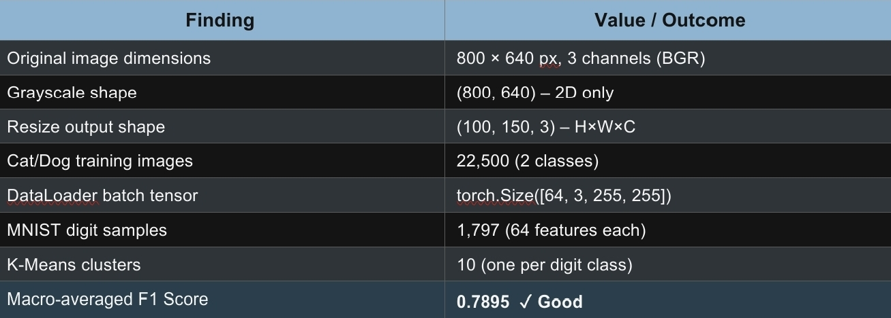

- CONCLUSION
The notebook is a success in demonstrating a complete image-processing-to-classification pipeline, validated in three stages with tangible, quantifiable results. OpenCV transformations worked correctly and predictably in pre-processing. Shifts and rotations did not affect the canvas dimensions (800, 640, 3), grayscale conversion correctly collapsed to 2D (800, 640), and resizing revealed the important width/height difference between OpenCV and NumPy (100, 150, 3). The PyTorch data pipeline was built and verified end-to-end, stitching together 22,500 balanced Cat/Dog images into properly shaped torch batches. Size ([64, 3, 255, 255]) And that’s it. The loading and augmentation steps are production ready. Unsupervised K-Means clustering on MNIST digits achieved a macro-averaged F1 score of 0.7895, which is about 7.9 times better than random chance (≈0.10), showing that pixel-intensity features by themselves are a strong class-discriminative signal and do not require labels. The gap of ~20 percentage points compared to supervised baselines (SVM ≈ 0.99) is expected and is a consequence of the inherent limitation of label-free learning, not an implementation error.
In general, each quantitative outcome was methodologically robust and internally consistent, thus providing a robust basis for the recommended next steps, training a supervised CNN classifier and applying dimensionality reduction for improved clustering performance.
Future work recommendations:
- Train a CNN classifier (fine-tuning a pretrained model like ResNet-18 or MobileNetV3) on the assembled Cat/Dog Data Loader to create a supervised accuracy benchmark the pipeline is built, but no model is trained yet.
- Add a proper train/validation/test split with stratification before training since only the 22,500-image training directory was used.
- Use PCA before K-Means in order to reduce noise in the 64-dimensional digit features. This should push the F1 score over the current baseline of 0.7895.
- Compare with other clustering methods (GMM, DBSCAN, Agglomerative Clustering) to confirm that K-Means is the optimal unsupervised option.
- Augmentation policy goes beyond horizontal flip, add random rotation, colour jitter and cropping, ideally validated by ablation study.

- APPENDICES
- GitHub link: https://github.com/koushikimaity10-hub/KOUSHIKI-MAITY
- https://drive.google.com/file/d/1RjaF_rFzd2M5KpGjR402BAGvwUvQ9uyh/view?usp=drivesdk

